**Project Development Phase Model Performance Test**

| Date | 19 November 2022 |
| --- | --- |
| Team ID | PNT2022TMID03886 |
| Project Name | Project - Corporate Employee Attrition Analytics |
| Maximum Marks | 10 Marks |

**Model Performance Testing:**

| **S No** | **Parameter** | **Screenshot / Values** |
| --- | --- | --- |
| 1. | Dashboard design | 14 |
| 2. | Data Responsiveness | Good |
| 3. | Amount Data to Rendered (DB2 Metrics) | 3 Datasets |
| 4. | Utilization of Data  Filters | Yes |
| 5. | Effective User Story | 4 Scenes |
| 6. | Descriptive Reports | 4 Reports |

**Dashboard – Visualizations**

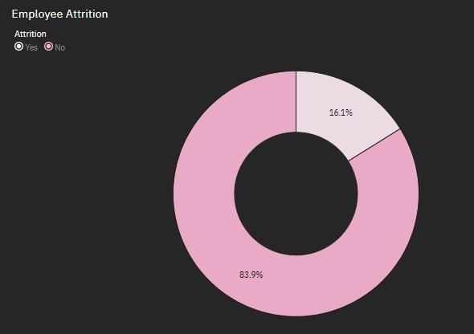

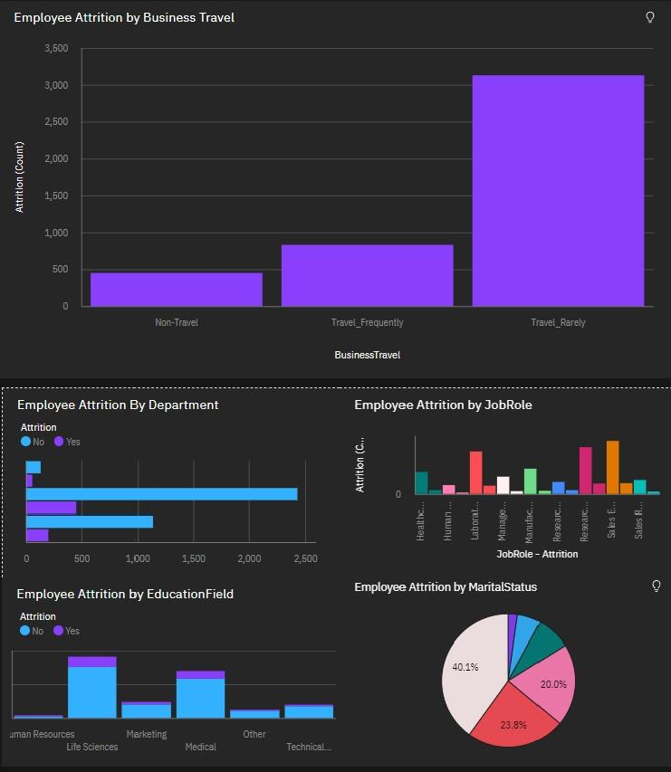

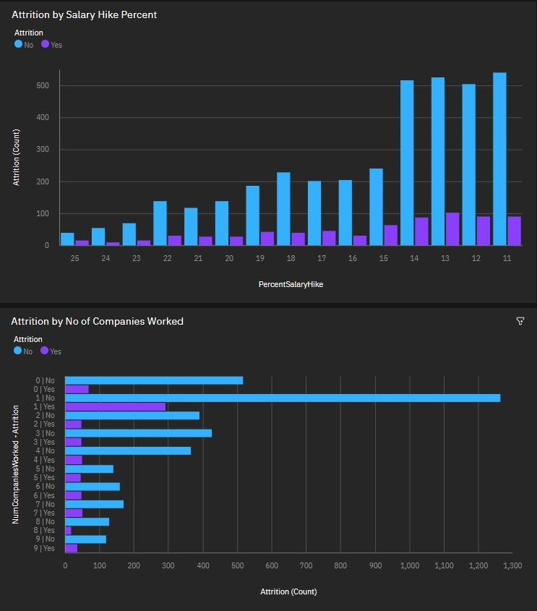

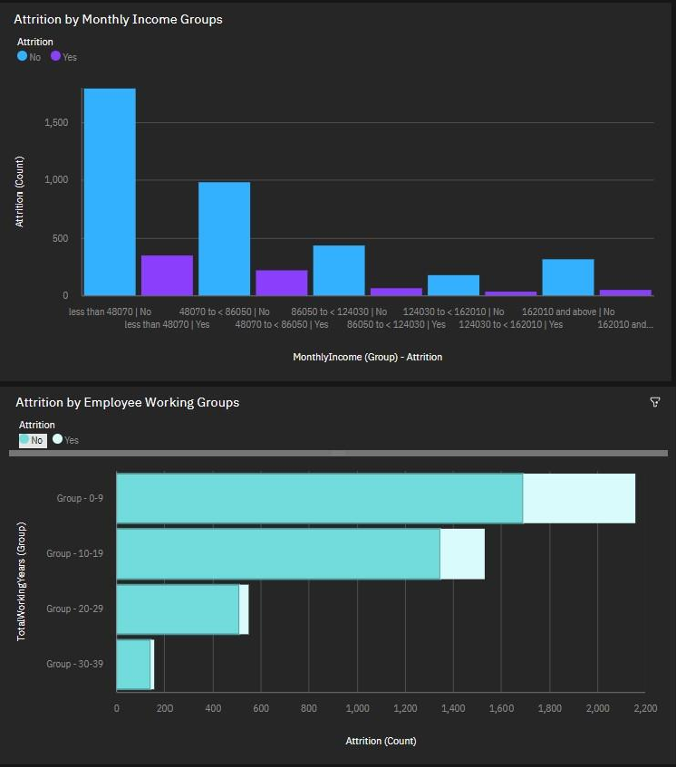

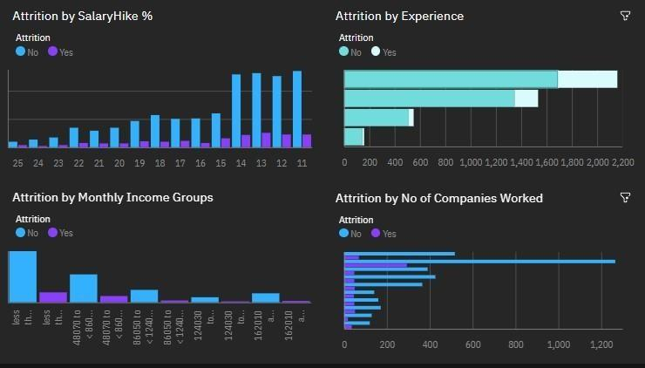

**Report**

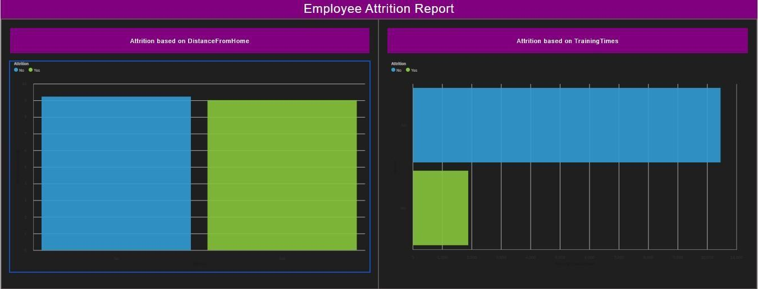

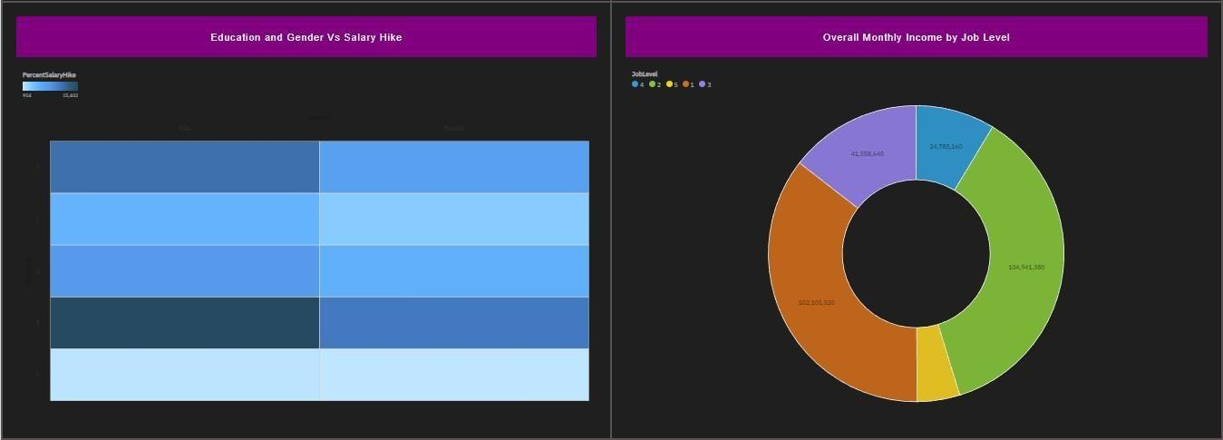

**Story**



